**ASSIGNMENT – 6 (Spark)**

**Task 6**

**SIRSS2235**

**Anannya Priyadarshini Neog**

Q1 : You need to show the userid, movieId, & timestamp column present in form of date  
for those movies whose rating is in between 3.0 and 5.0

Ans:-

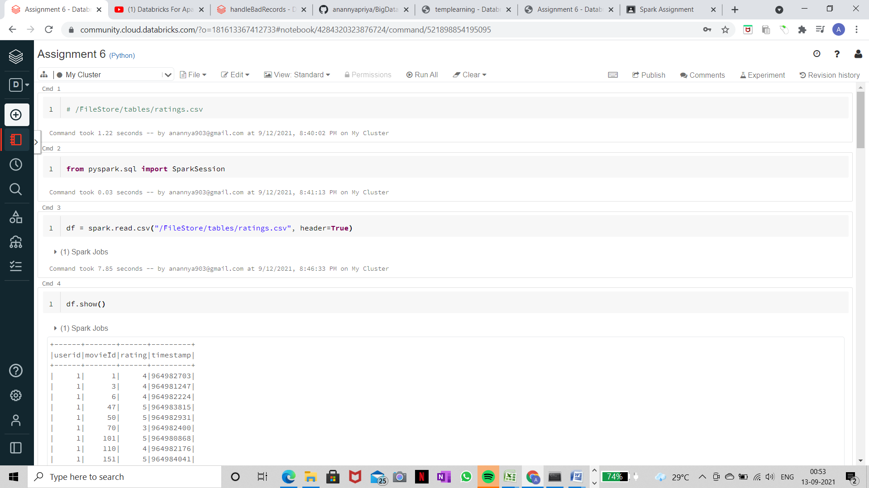

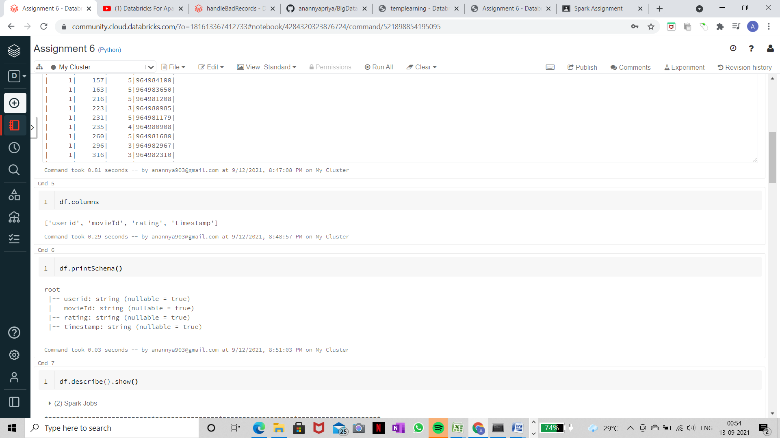

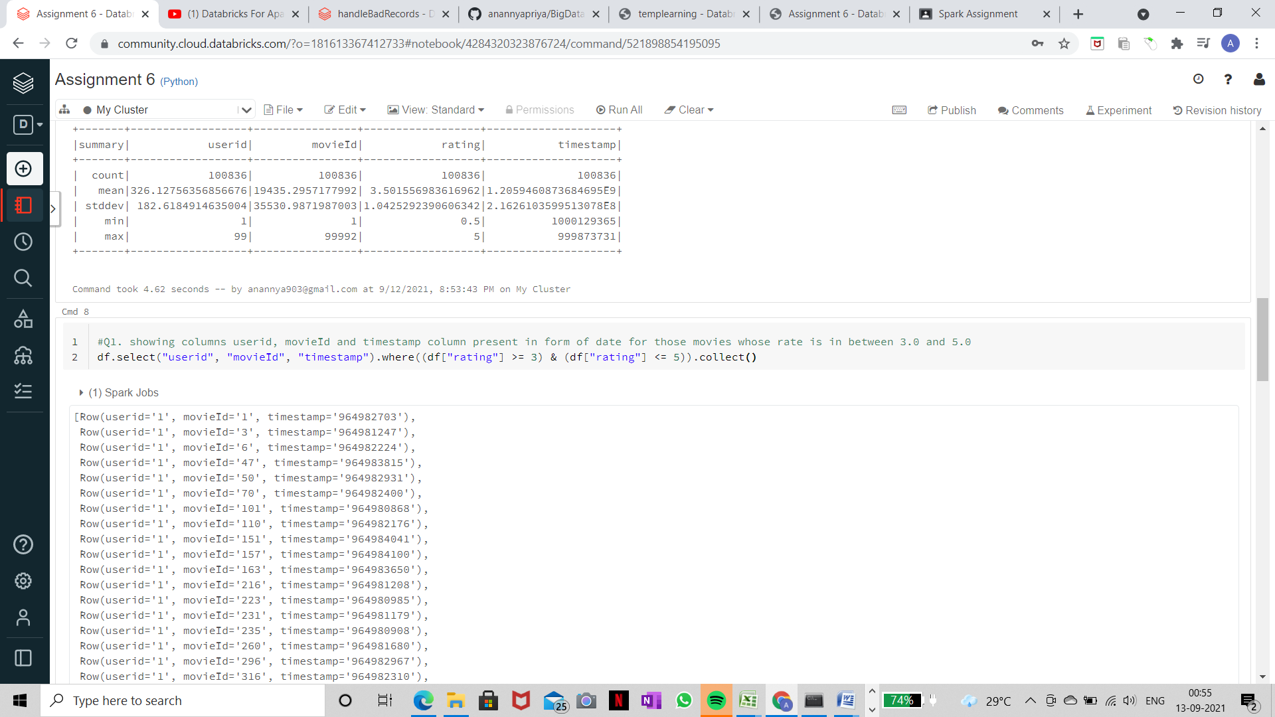

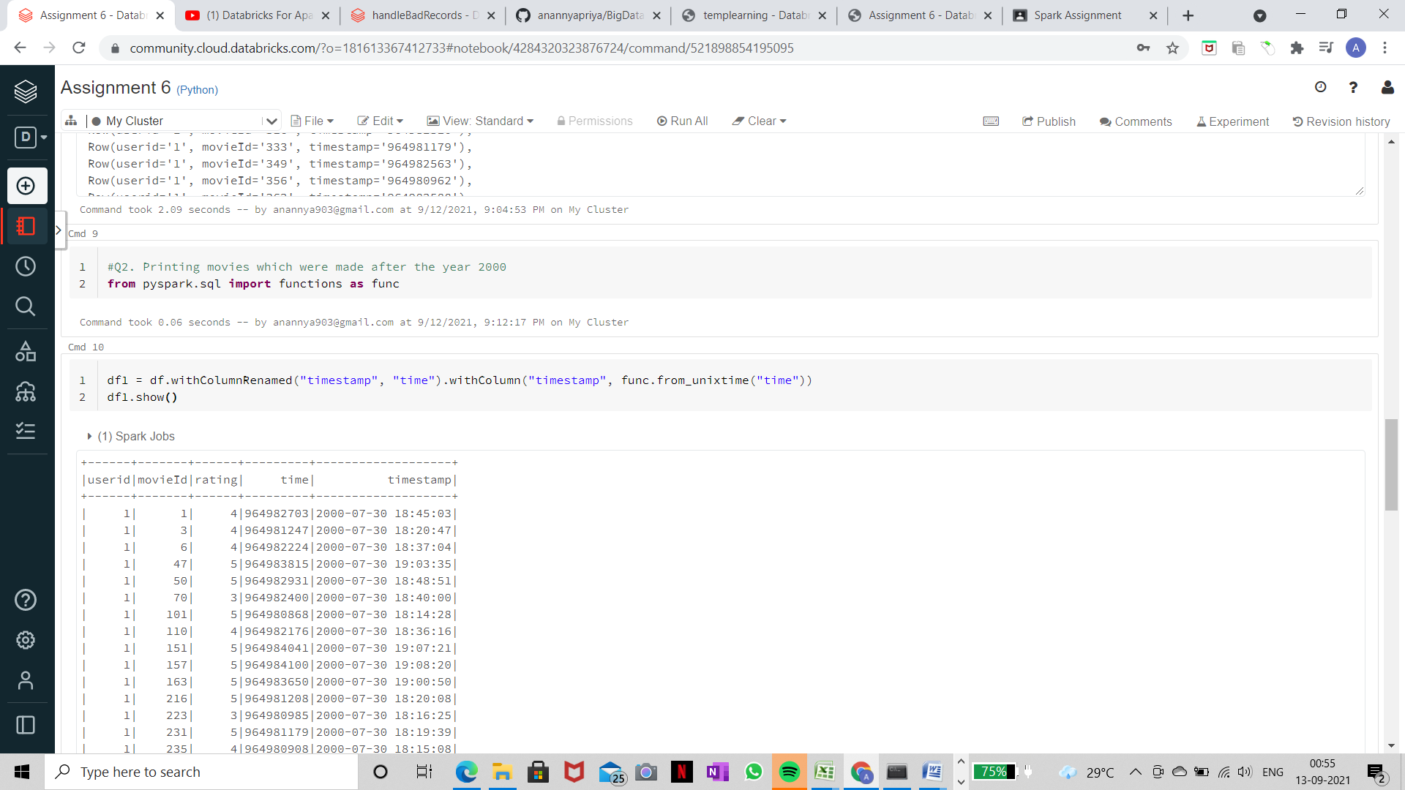

Q2 : You need to print the the movies which has been created after the year 2000

Ans:-



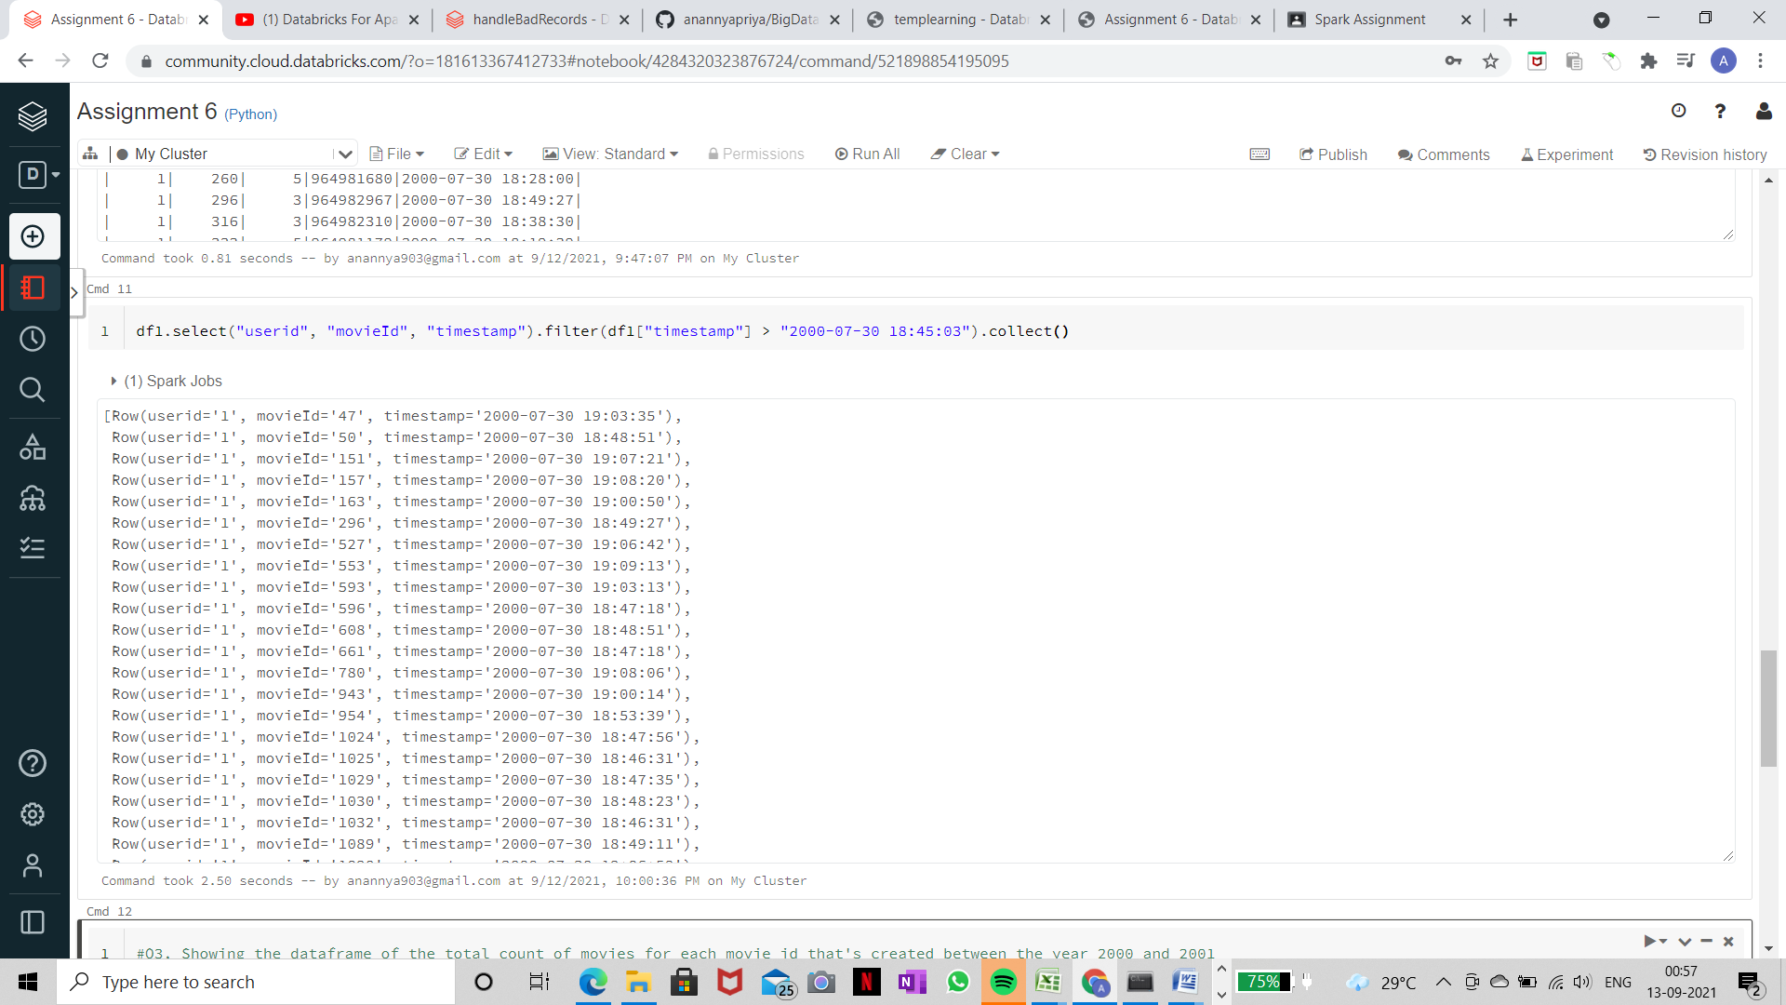

Q3 : You need to show in the dataframe what is the total count of movies for each movie id that is created between the year 2000 and 2001

Ans:-

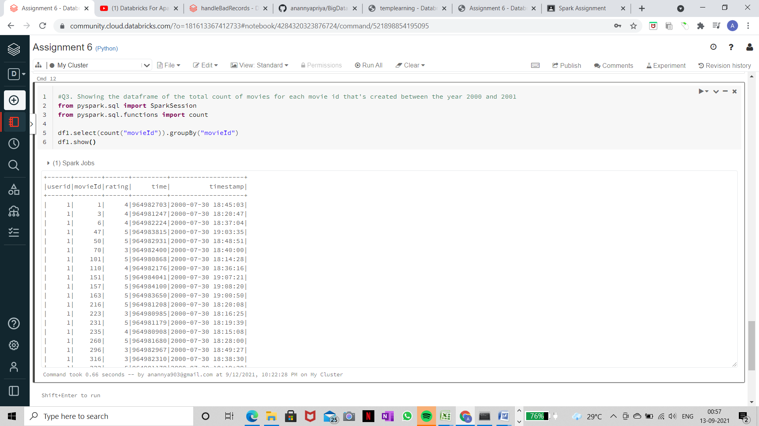

**\*\*LINK for the ipynb notebook :** <https://databricks-prod-cloudfront.cloud.databricks.com/public/4027ec902e239c93eaaa8714f173bcfc/181613367412733/4284320323876724/202762690136644/latest.html>